Open Trade

*(Technical report)*

Case study

Studying the market we observe the need to create an application which transparently offers distributors, manufacturers, simple customers a way of safe tracking of a product, service in a simple matter by scanning a QR code. Such a service is needed more than ever because the consumption of goods increased a lot and will continue to increase over time.

Tracing the origin of a product will improve the working conditions for millions of people in developing countries, while also ensuring fast and reliable callbacks for infected food products.

Trade is a basic economic concept involving buying and selling of goods and services, with compensation paid by a buyer to a seller, or the exchange of goods or services between parties. Trade can take place within an economy between producers and consumers.

We can see the need of this application by observing the value of international trade reported in 2018 in the world.

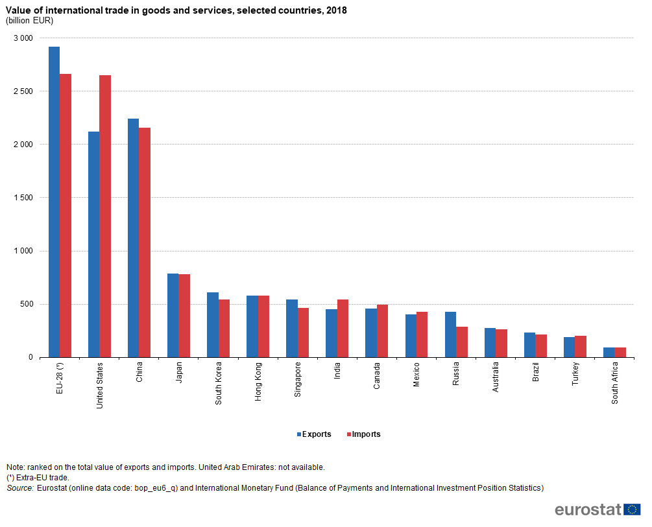

International trade between different countries is an important factor in raising living standards, providing employment and enabling consumers to enjoy a greater variety of goods.

Here we have a chart that exposes the growth in recent years.

World exports of goods and services have increased to $2.34 trillion ($23,400 billion) in 2016.

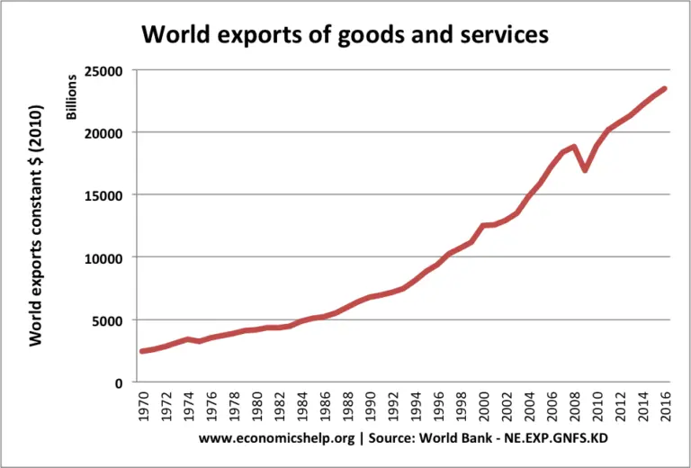

Some of the competitors:

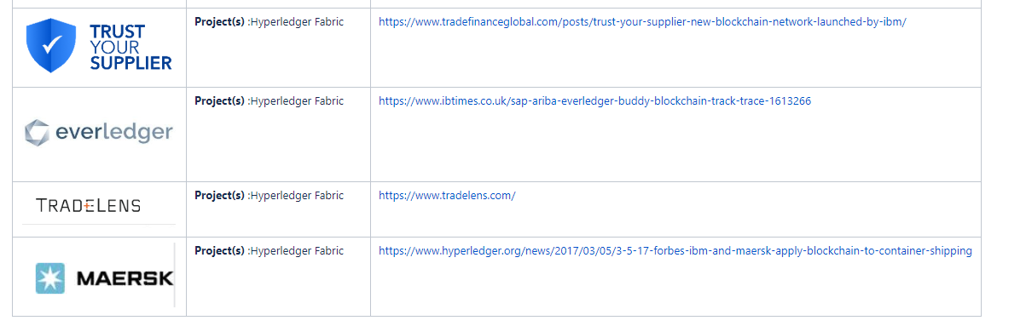

Business Canvas 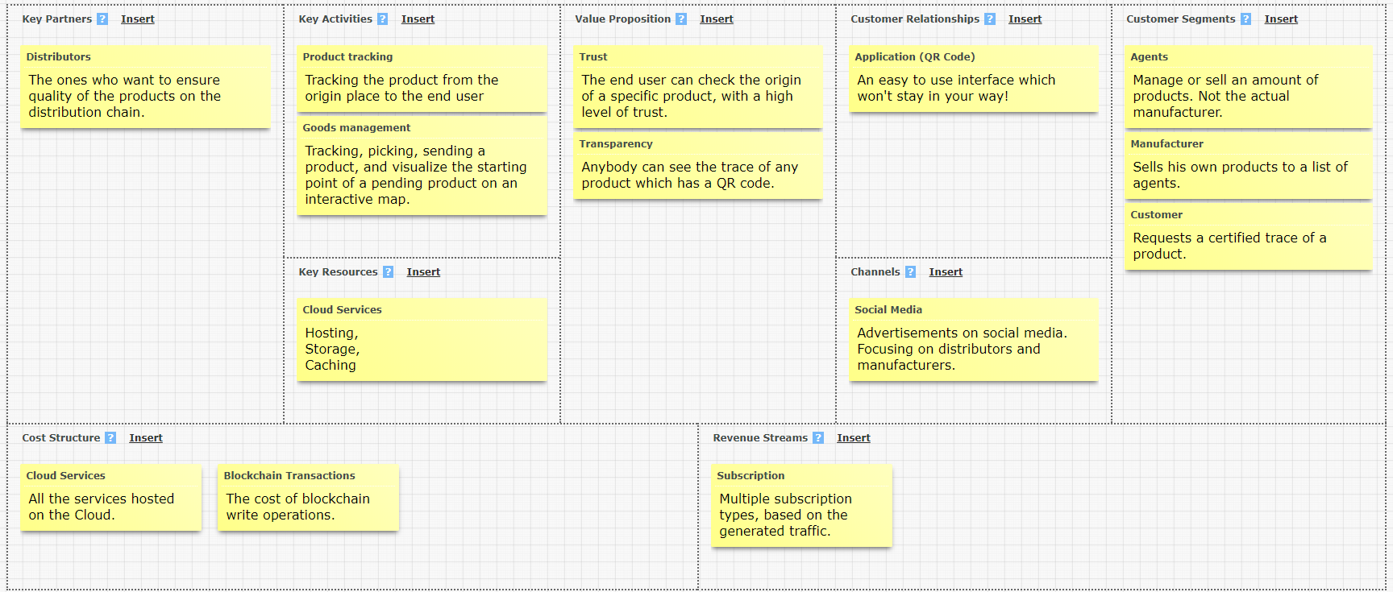

Technologies

Cloud services

1. **Redis**: an in memory database that we use to cache content and deliver a faster experience for our users.
2. **CosmosDb:** Azure Cosmos Db is a database designed by Microsoft for the cloud. It’s designed to be replicated and used at scale to deliver the performance needed for any application. We use it with the Mongo api.
3. **Maps:** Azure Here maps is the mapping solution offered by Microsoft
4. **Geolocation:** An api that provides us geographical location of cities and locations
5. **Azure Container Service**: a managed docker environment designed to be easy to use. We used it to run our Ethereum nodes and scale them on demand.
6. **App Service:** a scalable service to deploy web apps. We run our API like this
7. **Azure VM:** a simple IaaS service with a guaranteed uptime of 99.9% that we use to host our frontend server.

Other technologies

1. **Angular**: a battle tested frontend framework used to create single page applications power by Javascript. The code is organized in reusable components, data is dynamically updated in the DOM and the third-party library is vast.
2. **NodeJS**: a Javascript runtime for server side applications. It’s the best choice for our IO bound app. It enables one language to be used on the entire stack.
3. **Express**: a NodeJs web server with best in class features
4. **Metamask:** A cryptocurrency wallet that will sign Ethereum transactions for our system. It’s one of the most used wallets in the world.
5. **Ethereum**: Known as the computer of the world, Ethereum is a global blockchain network used by millions of people to create Daps.

Architectural diagram

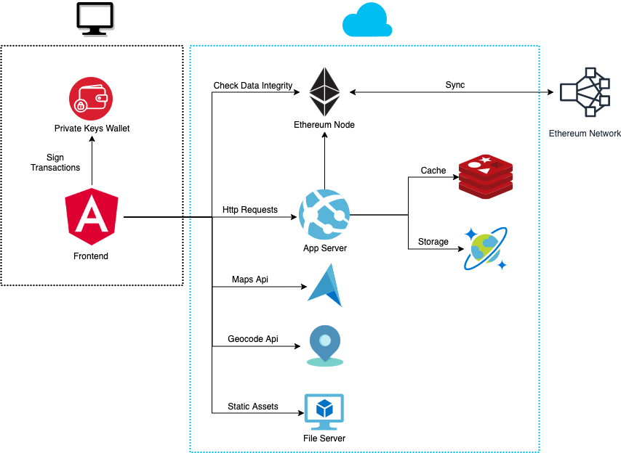

Use-case diagram

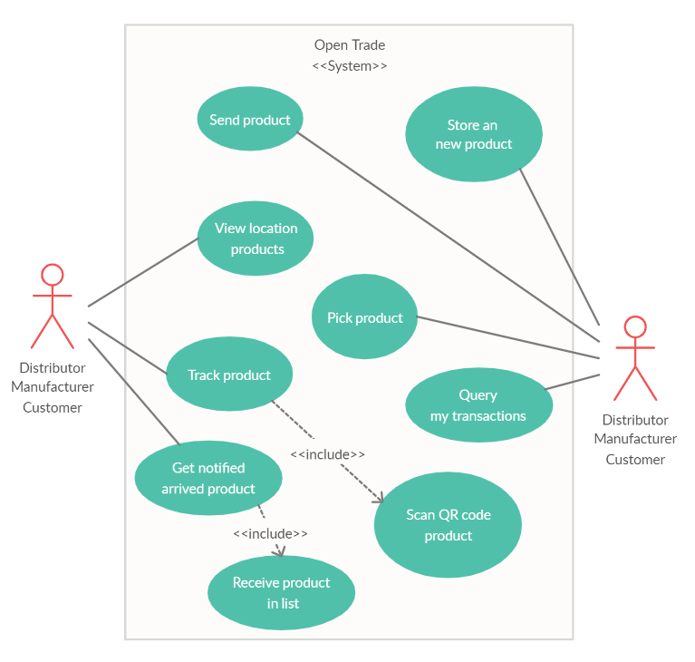

Resources

<https://wiki.hyperledger.org/pages/viewpage.action?pageId=31198435&fbclid=IwAR3rAALMtQD7aU7vx3tDYi_GxgETrZV8iJajnqhTR0x6k_V6jZwthCjROks>

<https://www.economicshelp.org/blog/58802/trade/the-importance-of-international-trade/>